Advanced Filtering

Learner Guide

CONTENTS

How to Use This Workbook 3

Advanced Filters 4

Defining the criteria range 4

Specifying criteria 5

Defining an advanced filter 6

# How to Use This Workbook

|  |  |  |  |
| --- | --- | --- | --- |
| C:\Users\wayazi\AppData\Local\Microsoft\Windows\INetCache\Content.Word\Courses.png | **Activity**  Alongside this icon you’ll find details of the group/individual activity or a point for everyone to discuss. | G:\Templates\Powerpoint\Additional icons\Employees.png | **Useful Tool**  This icon indicates a technique that will help you put what you learn into practice. |
|  | **Important Idea or Concept**  Generally, this icon is used to draw your attention to ideas that you need to understand by this point in the course. Let your trainer know if you do not understand or see the relevance of this idea or concept. | C:\Users\wayazi\AppData\Local\Microsoft\Windows\INetCache\Content.Word\Get-on-demand-skills.png | **Helpful Hint**  This icon guides you to tips or hints that will help you avoid the standard pitfalls that await the unwary practitioner or to show you how you might increase your effectiveness or efficiency in practising what you have learnt. |
| Relevant Skills | **Key Point**  This icon is used to indicate something that practitioners in this field should know. It’s likely to be one of the major things to remember from the course, so check you do understand these key points. |  | **Reference Material**  When we have only touched briefly on a topic this icon highlights where to look for additional information on the subject. It may also be used to draw your attention to International or National Standards or Web addresses that have interesting collections of information. |
|  | **Definition**  Where a word with a very specific definition (or one that could be described as jargon) is introduced this will highlight that a definition is provided. (These words will also be found in the Glossary at the back of the workbook.) |  | **Warning**  This icon is used to point out important information that may affect you and your use of the product or service in question. |

# Advanced Filters

While the standard filters provide an excellent and efficient method for filtering data, they only perform a filter within the single column; if you need to filter against multiple columns, it will be necessary to use Excel’s advanced filter.

For example, in a list of staff, it may be necessary to see all staff born before 1970 (using the ‘Date of Birth’ column) and all staff who are members of the company’s pension scheme (using the ‘Pension or Benefits’ column).

The data can be filtered in place as with a regular filter, or the search results placed elsewhere on the worksheet.

With advanced filters, criteria are entered into cells underneath the relevant column headings, rather than selecting from a tick list. This makes it possible to store regular or complex criteria in different ranges for quick retrieval.

When using advanced filter, it is necessary to setup the worksheet correctly. Typically, this will involve allocating two or three ranges to hold information:

* List range: the range of cells where the data list is located.
* Criteria range: cells that will hold the criteria, including a copy of the list’s headings.
* Copy to range: (optional) the cells where the results are to be copied to.

## Defining the criteria range

Unlike when using regular filtering, any search criteria is entered into a criteria range –an area of the worksheet that will contain the desired criteria. It must have the relevant column heading(s) in its first row, with subsequent rows containing criteria.

|  |  |
| --- | --- |
|  | **Key point** The column headings in the criteria range must match those in the list range exactly (although it is not case-sensitive). It is a good idea to copy the list’s column headings to the criteria range. |

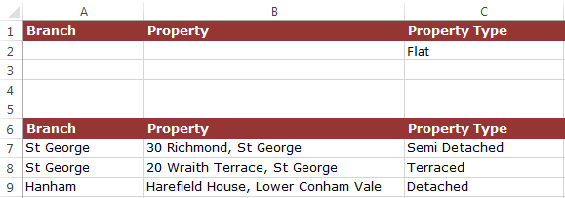

1. An advanced filter requires criteria to be entered into a criteria range (top)

### **Criteria range guidelines**

There are several things to consider when setting up a criteria range in a worksheet:

* The first row of the criteria range must be the column headings to be used in the filter. Whilst only the column headings to be used are needed, it may be easier to copy the entire row of column headings.
* Using one or more rows beneath each column heading, enter the information that is to be filtered in that column.
* Any values entered on the same row within the criteria range are joined by the AND operator (that is to say, all values on the row must be met).
* Using multiple rows in the criteria range joins them using an OR operator (in other words, any records matching the complete criteria on the first row, or any records matching the complete criteria on the second row, will be displayed).
* Column headings with no data under them are excluded from the filter.
* Duplicate column headings allow more than one set of criteria to be entered.
* An entirely blank row within the criteria range will result in all records being returned.
* The criteria range is best positioned either above or below the list range or on another worksheet – not to the side of the list. This is because Excel hides the entire row when performing a filter – if the criteria range is located to the side, it will be hidden from view.

## Specifying criteria

Using Excel’s advanced filtering command allows multiple criteria to be specified in a variety of ways.

### **Operators and wildcards**

When entering criteria, it may be necessary to specify values over or below a given value. **Operator symbols** can be used to achieve this:

|  |  |
| --- | --- |
| Symbol | Meaning |
| > | Greater than the specified value (e.g., >50) |
| >= | Greater than or equal to your specified value (e.g., >=50) |
| < | Less than the specified value (e.g., <50) |
| <= | Less than or equal to your specified value (e.g., <=50) |
| = | Equal to (e.g., =50). This is assumed by Excel, and there no need to specify it |
| <> | Not equal to (e.g., <>50) |

Additionally, **wildcard symbols** can be used within a filter:

|  |  |
| --- | --- |
| Symbol | Meaning |
| * | Replaces any number of characters (e.g., Chris* may return Chris, Christopher, Christian and Christine) |
| ? | Replace a single character (e.g., Re?d, may return Reid and Read; Sm?th may return Smith and Smyth) |

### **Filtering between values**

It may be necessary to return records where values fall between an upper and lower limit, such as dates or numbers. When using the advanced filtering tools, this can be achieved by adding a duplicate heading for the relevant column.

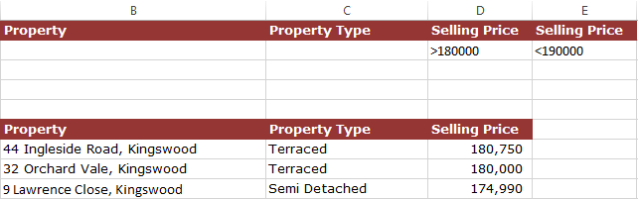

1. Using a ‘between’ advanced filter

## Defining an advanced filter

Once the data list (‘list range’) and criteria range have been allocated, the **Advanced Filter** dialog box can be used to setup and control how the filter will work.

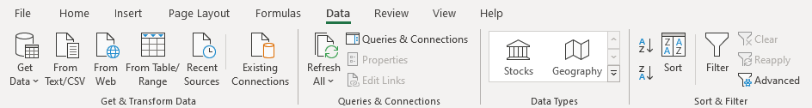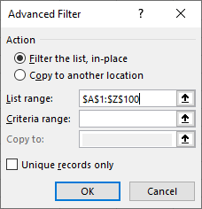

1. Setting up the advanced filtering command

The **Advanced Filter** dialog provides six options:

|  |  |
| --- | --- |
| Option | Description |
| Filter the list, in-place | This will hide non-matching rows from their current location (the same as the standard filter command) |
| Copy to another location | Matching records are copied to a different location |
| List range | The range of cells containing the data list. If the cell point is located within the list, the current region will automatically be entered here. |
| Criteria range | The range of cells containing the criteria and relevant column headings. Excel tends to remember the last‑used range if the dialog box has been used previously.  Excel will automatically name the last criteria range used, calling it ‘Criteria’ (worksheet scope). |
| Copy to | Used if you selected the ‘Copy to another location’ option. Specify where you want the matching records to appear. |
| Unique records only | Tells Excel to check for duplicate entries within the list. If every cell within one record matches another record, the second and subsequent records will not be copied. |

|  |  |
| --- | --- |
|  | **Helpful hint** Excel can be reluctant to copy the results of an advanced filter to a different worksheet, displaying an error message.  One way around this is to run the advanced filter command from the worksheet where the results are to appear. |

Let’s setup and use an advanced filter:

1. Open the **DATA LISTS.XLSX** workbook and navigate to the **Advanced** worksheet.
2. Copy the column headings, “Branch” and “Property type” and paste it to the first row, in columns I and J.
3. Enter any desired criteria below them. For example: enter “Fishponds” below “Branch” and “Flat” below “Property type”. These will be your criteria range.
4. Click Data > Advanced – Excel will display the ‘Advanced Filter’ dialog box.
5. Specify any desired settings and click OK.

|  |  |
| --- | --- |
|  | **Guided activity:**  **Using advanced filters** |

Your company has recently added some new members to the company car scheme. All Marketing department employees based in Aberdeen, earning between £35,000 and £45,000 and all full-time, Sheffield-based employees who joined before 2000 are eligible for the company car scheme at band C.

1. Ensure that the **DATA LISTS.XLSX** workbook is open and navigate to the **Employees** worksheet.
2. Sort the list into alphabetical order using the **Location** column.
3. Insert five rows at the top of the worksheet and paste a copy of the list’s headings into row one of the worksheet.

Now that the worksheet is prepared for a criteria range, you will enter the first set of criteria.

1. In row two, enter the following criteria under the specified headings:
   * Department: Marketing
   * Location: Aberdeen
   * Salary: >=35000
   * Car: No
2. In column M, enter a heading in the first row of Salary, and in M2 enter <=45000 (Excel will use this in conjunction with the salary criteria in column J).

With the first set of criteria specified, you will now enter further criteria.

1. In row three of the worksheet, enter the following criteria under the specified headings:
   * Location: Sheffield* - this will use any occurrence of Sheffield, north or south.
   * Hours per week: 35
   * Date joined: <01/01/2000
   * Car: No

You will now run the advanced filter using the criteria entered:

1. Select any cell in the list of data.
2. Click Data > Advanced, and configure the **Advanced Filter** dialog box as follows, and click OK:
   * Action: Filter the list, in‑place
   * List range: $A$6:$L$158
   * Criteria range: $A$1:$M$3
3. In the ‘Car’ column for the remaining records, enter C and click Data > Clear to remove the filter.

|  |  |
| --- | --- |
|  | **Guided activity:**  **Using the FILTER function** |

You will now extract a list of all employees who are in the company car scheme and place the results on the **Car Scheme** worksheet using the **FILTER** function.

1. Create a Range Name of **Staff** for the range A7:L158. Please refer to “DE3 Guide to Microsoft Excel.pdf” and “Working with Range Names” on the contents page, from page 95.
2. Move to cell A2 on the **Car Scheme** worksheet.
3. Enter the following formula:  
   **=FILTER(Staff,Employees!L7:L158<>"No")**
4. Save the workbook.
5. Name three elements of an advanced filter.
6. Please refer to **the Guide to Microsoft Excel.pdf** and complete the Dynamic array functions if you haven’t already. This covers UNIQUE, SORT and more on FILTER functions.

|  |  |
| --- | --- |
|  | **Key point**  Dynamic arrays are currently only available in Excel 365 and Excel 2021. As such, your instructor may elect not to cover them during the course. |